**Project Overview:**

I have named my project as ***Book-A-Vintage***. As the name suggests, this application helps customers to rent vintage cars in various locations and they can cancel it if their timings are not suitable. My project is a prototype of enterprise application.

In this application, I have placed mainly 4 locations such as Ashford, UNC Charlotte, UT North and UT Drive in my application. I also assumed that these locations are closed on Saturday and Sunday. Customer can add liability and damage coverage to their booking. Finally, after choosing booking customer will get the final amount he need to pay.

Customer can also cancel their rides. The customers can cancel his/her rides only before twenty-four hours of their travel time. Customers can also mail several doubts to the administrator through a form in contact page. The administrator will receive all those queries and send them the reply.

**Sitemap:**

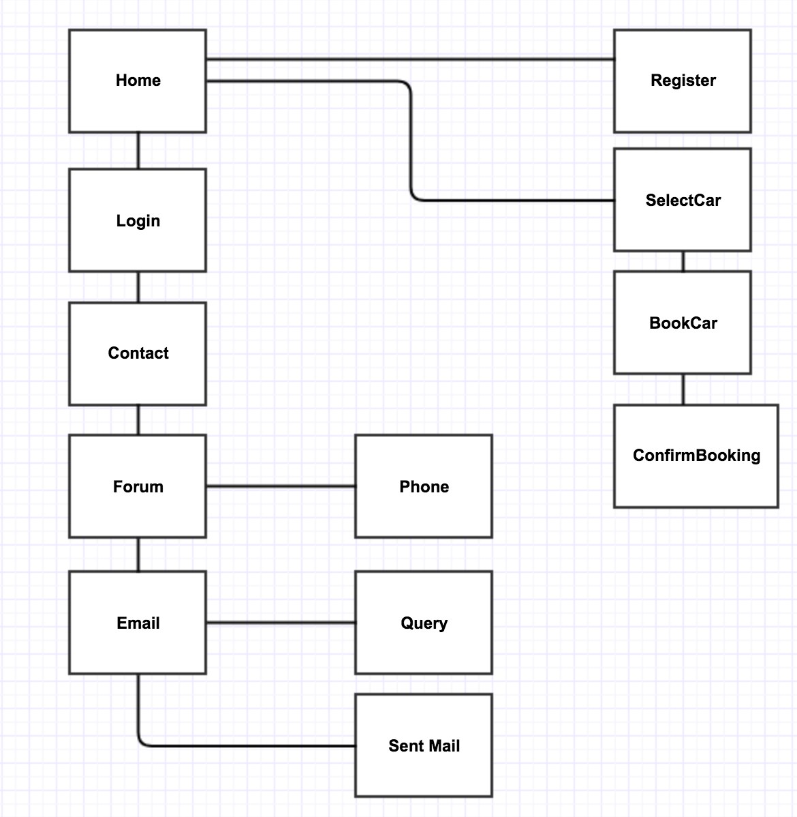

**Users and Access:**

Customers: - Using this application, the customer can create an account. He / She can book and cancel a vintage car as per their availability. Also, he/she can check their booking history.

Administrator: - Administrator can respond to various queries posted by the customer.

**Page Design:**

1. **Home Page:**

**Name of the page:** index.jsp

**Purpose of the page:** Starting page

**Audience of the page:** Customer and Admin

**Data fields:** NA

**Validations:** NA

**Buttons/Hyperlinks:**  Contact, Login, Book-A-Vintage, Join Us

**Special notes:** This is the main page of the application.

1. **Login Page:**

**Name of the page:** Login.jsp

**Purpose of the page:** To login into the account

**Audience of the page:** Customer and Admin

**Data fields:** Email & Password

**Validations:** Both fields should not be null

**Buttons/Hyperlinks:**  Contact, Home, New User? Sign Up, Forgot Password, Sign In,

Admin.

**Special notes:** This is the login page of the application

1. **Registration Page:**

**Name of the page:** register.jsp

**Purpose of the page:** Customer can create an account using the registration page.

**Audience of the page:** Customer

**Data fields:** First name, Last name, Email, Sex, Password, Confirm Password, Phone,

Age, Driving License ID, Zip code

**Validations:** All the fields should not be null

**Buttons/Hyperlinks:**  Sign Up

**Special notes:** This is the page used for creating an account so that customer can book any vintage car online.

1. **Car Selection Page:**

**Name of the page:** SelectCar.jsp

**Purpose of the page:** Car Selection page

**Audience of the page:** Customer

**Data fields:** N/A

**Validations:** N/A

**Buttons/Hyperlinks:**  My Booking, Book-A-Vintage

**Special notes:** This page is used for selecting any car from the given list of cars.

1. **Book Car Page:**

**Name of the page:** BookCar.jsp

**Purpose of the page:** Booking Car page

**Audience of the page:** Customer

**Data fields:** Pick-up location, pick-up date, pick-up time, drop-off date, drop-off time

**Validations:** pick-up date, pick-up time

**Buttons/Hyperlinks:**  Proceed

**Special notes:** This page is used for booking the selected car from a given set of timings.

1. **Confirm Car Page:**

**Name of the page:** ConfirmBooking.jsp

**Purpose of the page:** Booking Confirmation page

**Audience of the page:** Customer

**Data fields:** N/A

**Validations:** N/A

**Buttons/Hyperlinks:**  Confirm, Edit Personal Info, Contact, Home, Logout

**Special notes:** This displays the confirmation of the car you have booked.

1. **Contact Page:**

**Name of the page:** Contact.jsp

**Purpose of the page:** Contact Information page

**Audience of the page:** Customer

**Data fields:** Name, Email, Mobile, Query

**Validations:** All the fields should not be null

**Buttons/Hyperlinks:**  Submit, Home, Login, View larger map

**Special notes:** This page is useful to submit any query to the administrator.

1. **Admin Welcome Page:**

**Name of the page:** WelcomeAdmin.jsp

**Purpose of the page:** Query Display page

**Audience of the page:** Administrator

**Data fields:** N/A

**Validations:** N/A

**Buttons/Hyperlinks:**  Reply, Sent Mails, Logoff

**Special notes:** This page is the main page which will be displayed once the administrator logs in.

1. **Reply Page:**

**Name of the page:** SendReply.jsp

**Purpose of the page:** Sends Reply to requested Query

**Audience of the page:** Administrator

**Data fields:** subject

**Validations:** subject cannot be null

**Buttons/Hyperlinks:**  Submit, Home, Sent Mails, Log off

**Special notes:** This page sends reply to the customer who have raised the query.

1. **Sent Mail Page:**

**Name of the page:** SentMail.jsp

**Purpose of the page:** To check previous queries

**Audience of the page:** Administrator

**Data fields:** N/A

**Validations:** N/A

**Buttons/Hyperlinks:**  Sent mails, Logoff

**Special notes:** This page has previous queries and shows the message “Your message has been sent” to those queries for which the administrator replied.

**ER Diagram:**

